SOCY7706: Longitudinal Data Analysis
Instructor: Natasha Sarkisian
Describing Longitudinal Data

Next, we examine some tools that allow us to describe change using longitudinal data. We will use an example from HRS data that focuses on employment and caregiving.

. use http://sarkisian.net/socy7706/hrs_hours.dta

. reshape long r@workhours80 r@poorhealth r@married r@totalpar r@siblog h@childlg r@allparhelptw, i(hhid pn) j(wave)
(note: j = 1 2 3 4 5 6 7 8 9)

Data wide -> long
-----------------------------------------------------------------------------
Number of obs. 6591 -> 59319
Number of variables 75 -> 20
j variable (9 values) -> wave
xij variables:
r1workhours80 r2workhours80 ... r9workhours80->rworkhours80
r1poorhealth r2poorhealth ... r9poorhealth-> rpoorhealth
r1married r2married ... r9married -> rmarried
r1totalpar r2totalpar ... r9totalpar -> rtotalpar
r1siblog r2siblog ... r9siblog -> rsiblog
h1childlg h2childlg ... h9childlg -> hchildlg
r1allparhelptw r2allparhelptw ... r9allparhelptw->rallparhelptw
-----------------------------------------------------------------------------

. tab wave
wave | Freq. Percent Cum.
------------+-----------------------------------
1 | 6,591 11.11 11.11
2 | 6,591 11.11 22.22
3 | 6,591 11.11 33.33
4 | 6,591 11.11 44.44
5 | 6,591 11.11 55.56
6 | 6,591 11.11 66.67
7 | 6,591 11.11 77.78
8 | 6,591 11.11 88.89
9 | 6,591 11.11 100.00
------------+-----------------------------------
Total | 59,319 100.00

To keep things simpler for now, we will keep only two time points, but use preserve to return to the full data.

. preserve

. keep if wave<3
(46137 observations deleted)

Stata provides a number of tools for analyzing panel data. The commands all begin with the prefix xt. To use these commands, we first need to tell Stata that our dataset is a panel dataset. We need to have a variable that identifies the units (for example, a country or person id) and a time variable. To set a dataset as a panel, we need to use xtset command:

. xtset hhidpn wave
panel variable: hhidpn (strongly balanced)
time variable: wave, 1 to 2
delta: 1 unit

Stata thinks the dataset is strongly balanced, meaning all units are observed at all time points (at the same time and equal number of times). But it is not true – we just have empty rows that were created when we went from wide to long format.

. xtdes

hhidpn: 10003020, 10004010, ..., 99564010 n = 6591
wave: 1, 2, ..., 2 T = 2
Delta(wave) = 1 unit
Span(wave) = 2 periods
(hhidpn*wave uniquely identifies each observation)

Distribution of T_i: min 5% 25% 50% 75% 95% max
2 2 2 2 2 2 2

Freq. Percent Cum. | Pattern
---------------------------+---------
6591 100.00 100.00 | 11
---------------------------+---------
6591 100.00 | XX

Xtdes also thinks all cases are complete. We will now delete those empty records to have a more accurate picture. Note that those rows are not completely empty – time-invariant variables still have values there, but the time-variant ones are empty. So we will only specify time-varying variables in the egen command:

. egen miss=rowmiss( rworkhours80 rpoorhealth rmarried rtotalpar rsiblog hchildlg rallparhelptw)

. tab miss
miss | Freq. Percent Cum.
------------+-----------------------------------
0 | 11,327 85.93 85.93
1 | 1,017 7.72 93.64
2 | 115 0.87 94.52
3 | 90 0.68 95.20
4 | 7 0.05 95.25
5 | 3 0.02 95.27
6 | 364 2.76 98.04
7 | 259 1.96 100.00
------------+-----------------------------------
Total | 13,182 100.00

. drop if miss==7
(259 observations deleted)

. xtset hhidpn wave
panel variable: hhidpn (unbalanced)
time variable: wave, 1 to 2
delta: 1 unit

This is more accurate now, and xtdes also shows that there are missing observations at time 2.

. xtdes

hhidpn: 10003020, 10004010, ..., 99564010 n = 6591
wave: 1, 2, ..., 2 T = 2
Delta(wave) = 1 unit
Span(wave) = 2 periods
(hhidpn*wave uniquely identifies each observation)

Distribution of T_i: min 5% 25% 50% 75% 95% max
1 2 2 2 2 2 2
Freq. Percent Cum. | Pattern
---------------------------+---------
6332 96.07 96.07 | 11
259 3.93 100.00 | 1.
---------------------------+---------
6591 100.00 | XX

Next, let’s examine change in a continuous variable.
. xtsum rworkhours80
Variable | Mean Std. Dev. Min Max | Observations
-----------------+--------------------------------------------+----------------
rwork~80 overall | 29.53971 22.79859 0 80 | N = 12477
between | 21.33473 0 80 | n = 6580
within | 8.392351 -10.46029 69.53971 | T-bar = 1.8962

Here we see overall standard deviation along with between and within standard deviations – between indicates the amount of variation across individuals (cross-sectional variation, or differences among individuals that are stable over time), and within indicates change over time within individuals (temporal variation). Between variation is essentially variation of average values for individuals over time, and within variation is variation in differences between values at each time point and averages for a given individual (i.e. individual’s deviation from their own overall mean). That is why the minimum and maximum differ from those for overall and between, and can be negative. Moreover, the way they calculate minimum and maximum is such that these are not just differences from the individual’s mean, but such differences plus the overall mean (in this case, 29.5). So the person who has 69.5 (maximum value) in fact only differs from his or her own mean by 69.5-29.5=40 hours. And the minimum value, -10.5, is in fact -10.5-29.5=-40. So it is fairly symmetric, which is what we would expect. Observation column shows that there are 12477 records, 6580 individuals, and an average of 1.8962 time points per person.

So this output allows us to decompose the variance in the variable we are describing into variance components -- into within-group and between-group variance (although they are expressed as standard deviations – to get variances, we’d have to square them). That does not explain anything, but it allows us to evaluate whether there is variation in group means (here, person-specific means), and how much of it. That’s why it is always a good idea to run this basic model when starting the analyses – it’s the null model of our regression analysis. If we find that there is no significant variation across individuals, then there is no need to adjust for the fact that clusters of observations come from the same individuals because all individuals are pretty much the same.

The proportion of variance due to group-level variation in means can be calculated as
ρ = S²_{between} / (S²_{between} + S²_{within})
It can be interpreted as the proportion of variance due to differences across individuals. It can also be interpreted as the average correlation between two randomly chosen time points that are in the same unit; therefore, it is also known as intra-class correlation. Here, we get:
. di 21.33473^2 / (21.33473^2 + 8.392351^2)
.86599838

So 87% of the total variance in hours of work is due to person-specific effects; the rest is due to changes that individuals experience over time.

To examine change in categorical variables, we can use both xttab and xttrans.

. xttab rmarried
Overall Between Within
rmarried | Freq. Percent Freq. Percent Percent
----------+-----------------------------------------------------
0 | 2662 21.20 1532 23.24 92.13
1 | 9895 78.80 5300 80.41 97.73
----------+-----------------------------------------------------
Total | 12557 100.00 6832 103.66 96.47
(n = 6591)
Here we can see that overall, out of all records in the data, 78.8% indicate that the person is currently married, and 21.2% indicate that the person is currently single. Between percent indicates that 80.41% of all individuals in the data were married at some point during the study (or in this case that means that they were married at either wave 1 or wave 2), and 23.24% of individuals were single at some point during the study period. The total is larger than 100 because any person who experienced both marriage and singlehood over this time period will be counted twice. Within percent indicates that among those individuals that were married at some point, they were married 97.73% of all of their data points, and among those who were single at some point, they were single 92.13% of all of their data points. The total for within is a weighted average – the number of people with at least one 0 multiplied by the proportion of 0s among these people’s records + the number of people with at least one 1 multiplied by the proportion of 1s among these people’s records, all divided by the total of those with at least one 1 and those with at least one 0. So here:
. di (1532*.9213+5300*.9773)/(1532+5300)
.96474262

. xttrans rmarried, freq
| rmarried
rmarried | 0 1 | Total
-----------+----------------------+----------
0 | 1,130 87 | 1,217
| 92.85 7.15 | 100.00
-----------+----------------------+----------
1 | 154 4,595 | 4,749
| 3.24 96.76 | 100.00
-----------+----------------------+----------
Total | 1,284 4,682 | 5,966
| 21.52 78.48 | 100.00

Xttrans shows transitions among statuses: so here we see that among those who were married at time point 1, 96.76% were still married at time point 2, while 3.24% were no longer married. Of those who were single at time 1, 92.85% were still single at time 2 and 7.15% were no longer single.

If we have more than 2 time points, xttab and xttrans put them all together. For example, let’s go back to all 9 waves.
. restore

Let’s once again get rid of those “empty” observations (with no data for a given wave):
. egen miss=rowmiss( rworkhours80 rpoorhealth rmarried rtotalpar rsiblog hchildlg rallparhelptw)

. tab miss

miss | Freq. Percent Cum.
------------+-----------------------------------
0 | 30,546 51.49 51.49
1 | 15,030 25.34 76.83
2 | 1,435 2.42 79.25
3 | 143 0.24 79.49
4 | 7 0.01 79.50
5 | 3 0.01 79.51
6 | 7,512 12.66 92.17
7 | 4,643 7.83 100.00
------------+-----------------------------------
Total | 59,319 100.00

. drop if miss==7
(4643 observations deleted)

. xtset hhidpn wave
panel variable: hhidpn (unbalanced)
time variable: wave, 1 to 9, but with gaps
delta: 1 unit

Let’s save this file:
. save hrs_hours_long.dta

And now we can describe the data:
. xtdes

hhidpn: 10003020, 10004010, ..., 99564010 n = 6591
wave: 1, 2, ..., 9 T = 9
Delta(wave) = 1 unit
Span(wave) = 9 periods
(hhidpn*wave uniquely identifies each observation)

Distribution of T_i: min 5% 25% 50% 75% 95% max
1 3 9 9 9 9 9

Freq. Percent Cum. | Pattern
---------------------------+-----------
5540 84.05 84.05 | 111111111
154 2.34 86.39 | 11.......
137 2.08 88.47 | 1........
84 1.27 89.74 | 1111.....
81 1.23 90.97 | 11111....
73 1.11 92.08 | 11111111.
69 1.05 93.13 | 111......
55 0.83 93.96 | 1111111..
49 0.74 94.70 | 111111...
349 5.30 100.00 | (other patterns)
---------------------------+-----------
6591 100.00 | XXXXXXXXX

. xtsum rworkhours80 rpoorhealth rmarried rtotalpar rsiblog hchildlg rallparhelptw

Variable | Mean Std. Dev. Min Max | Observations
-----------------+--------------------------------------------+----------------
rwork~80 overall | 19.67817 22.46339 0 80 | N = 46661
between | 17.10868 0 80 | n = 6587
within | 15.5263 -48.89326 90.78928 | T-bar = 7.0838
| |
rpoorh~h overall | .2340638 .4234167 0 1 | N = 47141
between | .3401185 0 1 | n = 6591
within | .2765936 -.6548251 1.122953 | T-bar = 7.15233
| |
rmarried overall | .7463865 .4350836 0 1 | N = 47115
between | .3947182 0 1 | n = 6591
within | .1958791 -.1425024 1.635275 | T-bar = 7.14838
| |
rtotal~r overall | .8884476 .8662165 0 4 | N = 46830
between | .6585949 .1111111 4 | n = 6591
within | .6045806 -2.111552 4.138448 | T-bar = 7.10514
| |
rsiblog overall | 1.616775 .6256698 0 3.555348 | N = 54595
between | .6154972 0 3.218876 | n = 6588
within | .1870047 -.0368364 3.663518 | T-bar = 8.28704
| |
hchildlg overall | 1.126299 .5481416 0 2.944439 | N = 44219
between | .5389137 0 2.876082 | n = 6272
within | .1319155 -.4992974 2.794222 | T-bar = 7.05022
| |
rallpa~w overall | 1.652933 4.103339 0 19.23077 | N = 32727
between | 2.651108 0 19.23077 | n = 6588
within | 3.228803 -14.14377 18.74695 | T-bar = 4.96767

. for var rpoorhealth rmarried : xttab X

-> xttab rpoorhealth
Overall Between Within
rpoorhe~h | Freq. Percent Freq. Percent Percent
----------+-----------------------------------------------------
0 | 36107 76.59 5995 90.96 82.10
1 | 11034 23.41 3285 49.84 50.82
----------+-----------------------------------------------------
Total | 47141 100.00 9280 140.80 71.02
(n = 6591)

-> xttab rmarried
Overall Between Within
rmarried | Freq. Percent Freq. Percent Percent
----------+-----------------------------------------------------
0 | 11949 25.36 2404 36.47 70.58
1 | 35166 74.64 5455 82.76 89.72
----------+-----------------------------------------------------
Total | 47115 100.00 7859 119.24 83.87
(n = 6591)
. for var rpoorhealth rmarried : xttrans X

-> xttrans rpoorhealth
rpoorhealt | rpoorhealth
h | 0 1 | Total
-----------+----------------------+----------
0 | 89.35 10.65 | 100.00
1 | 28.72 71.28 | 100.00
-----------+----------------------+----------
Total | 76.09 23.91 | 100.00

-> xttrans rmarried
| rmarried
rmarried | 0 1 | Total
-----------+----------------------+----------
0 | 95.77 4.23 | 100.00
1 | 3.49 96.51 | 100.00
-----------+----------------------+----------
Total | 26.10 73.90 | 100.00

It could also be helpful to continue looking at specific transitions, either taking two waves at a time or as sequences of transitions over a number of waves. The latter approach led to a technique called sequence analysis (or social sequence analysis when used in social sciences). If interested, see, for example, “Social Sequence Analysis” book by Benjamin Cornwall (2015). To see some basic sequences, let’s use a special package:

. net search sequence
(contacting http://www.stata.com)

33 packages found (Stata Journal and STB listed first)
------------------------------------------------------

st0244 from http://www.stata-journal.com/software/sj12-1
SJ12-1 st0244. Scrambled Halton sequences in Mata / Scrambled Halton
sequences in Mata / by Stanislav Kolenikov, University of Missouri,
Columbia, USA / Support: skolenik@gmail.com

st0111 from http://www.stata-journal.com/software/sj6-4
SJ6-4 st0111. Sequence analysis with Stata / Sequence analysis with Stata
/ by Christian Brzinsky-Fay, Wissenschaftszentrum Berlin / Ulrich Kohler,
Wissenschaftszentrum Berlin / Magdalena Luniak, Wissenschaftszentrum
Berlin / Support: brzinsky-fay@wz-berlin.de, kohler@wz-berlin.de,

st0103 from http://www.stata-journal.com/software/sj6-2
SJ6-2 st0103. Generating Halton sequences using Mata / Generating Halton
sequences using Mata / by David Drukker, StataCorp / Richard Gates,
StataCorp / Support: rgates@stata.com / After installation, type help
sj_halton

dm55 from http://www.stata.com/stb/stb43
STB-43 dm55. Generating sequences and patterns of numeric data. / STB
insert by R. Mark Esman, Stata Corporation. / Support: mesman@stata.com /
After installation, see help fill.

dm44 from http://www.stata.com/stb/stb37
STB-37 dm44. Sequences of integers. / STB insert by Nicholas J. Cox,
University of Durham, UK. / Support: n.j.cox@durham.ac.uk / After
installation, see help seq.

sadi from http://teaching.sociology.ul.ie/sadi
Sequence Analysis Distance Measures / {bf: Brendan Halpin, Dept of
Sociology, Univer
--Break--
r(1);

We will install st0111 from http://www.stata-journal.com/software/sj6-4

. sqset rmarried hhidpn wave

Note: Some sequences contains gaps
Consider option -keeplongest-

Note: Some sequences have missings at the end
Consider option -rtrim-

element variable: rmarried, 0 to 1, and missings
identifier variable: hhidpn, 10003020 to 99564010
order variable: wave, 1 to 9

. sqtab

Sequence-Pa |
ttern | Freq. Percent Cum.
------------+-----------------------------------
111111111 | 2,283 41.74 41.74
000000000 | 508 9.29 51.03
111 | 209 3.82 54.85
1 | 206 3.77 58.62
11 | 194 3.55 62.17
11111 | 165 3.02 65.19
1111 | 157 2.87 68.06
11111111 | 155 2.83 70.89
111111 | 120 2.19 73.08
1111111 | 117 2.14 75.22
111111110 | 93 1.70 76.92
00 | 75 1.37 78.30
0 | 73 1.33 79.63
111000000 | 70 1.28 80.91
111110000 | 62 1.13 82.04
111111100 | 59 1.08 83.12
111111000 | 57 1.04 84.17
110000000 | 54 0.99 85.15
0000 | 52 0.95 86.10
00000 | 50 0.91 87.02
111100000 | 49 0.90 87.91
100000000 | 48 0.88 88.79
00000000 | 45 0.82 89.61
000 | 41 0.75 90.36
0000000 | 39 0.71 91.08
011111111 | 36 0.66 91.74
000000 | 24 0.44 92.17
000011111 | 22 0.40 92.58
10 | 11 0.20 92.78
110 | 11 0.20 92.98
11111110 | 11 0.20 93.18
…[output omitted]…
111110110 | 1 0.02 99.98
11111101 | 1 0.02 100.00
------------+-----------------------------------
Total | 5,469 100.00
While all of these tools are helpful to better understand the nature of change in your data, such analyses rarely directly appear in articles using longitudinal data – typically, tables of descriptive statistics take one of the following approaches, or some combination:
- Show means (and standard deviations) for each year, or some select years (e.g., the first and last year of the time sequence), or select ages – this approach aims to show how various variables in the study changed over time, but does not target change within individuals.
- Show means and standard deviations for pooled data (entire long dataset, where units are person-years or country-years, etc.). This does not focus on change over time (either overall or individual) but rather aims at describing the dataset overall.
- Show averages or frequencies of changes, transitions, or trajectories of individuals.
Examples: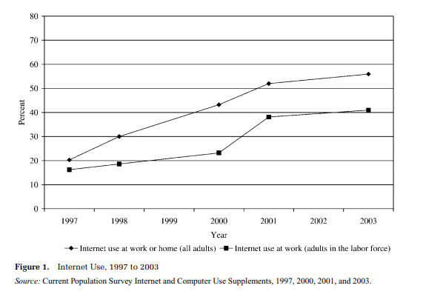
From: DiMaggio, Paul, and Bart Bonikowski. 2008. “Make Money Surfing the Web? The Impact of Internet Use on the Earnings of U.S. Workers.” American Sociological Review 73: 227–250.
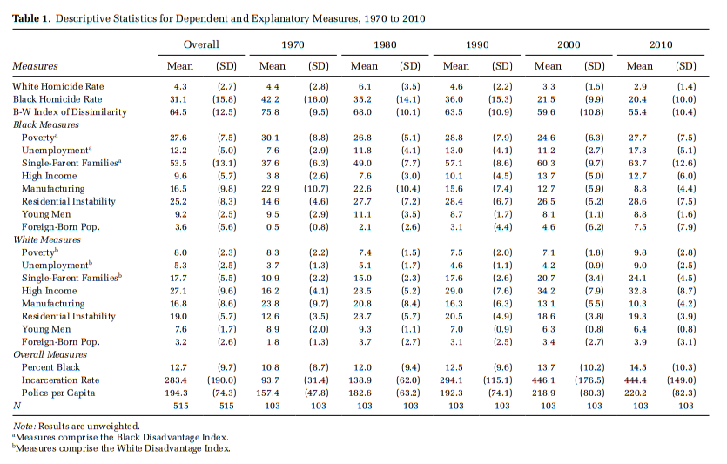
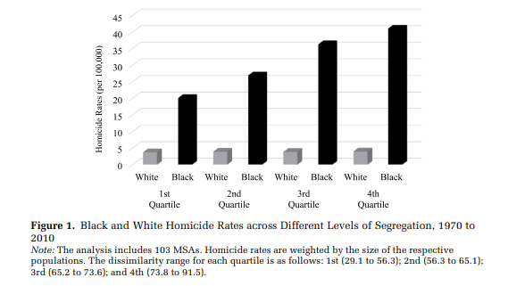
From: Light, Michael T. and Julia T. Thomas. 2019. “Segregation and Violence Reconsidered: Do Whites Benefit from Residential Segregation?” American Sociological Review, 84(4): 690–725.
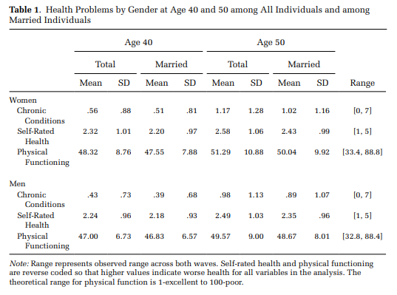
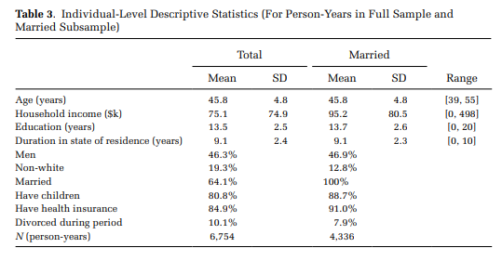
From: Homan, Patricia. 2019. “Structural Sexism and Health in the United States: A New Perspective on Health Inequality and the Gender System.” American Sociological Review, 84(3): 486–516.

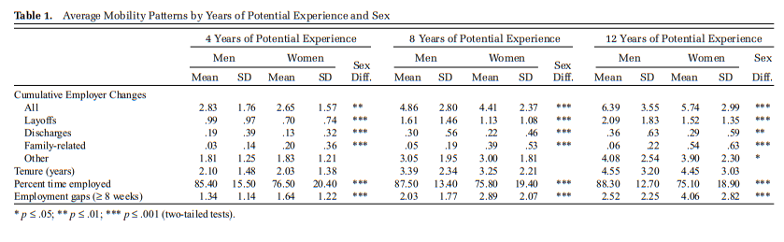
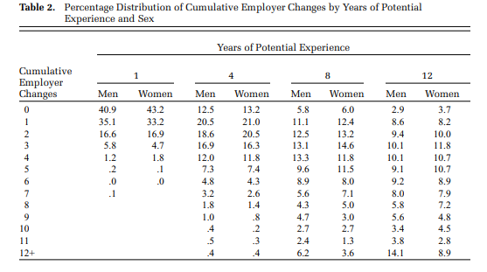
From: Fuller, Sylvia. 2008. “Job Mobility and Wage Trajectories for Men and Women in the United States.” American Sociological Review 73: 158–183.
Let’s look at similar descriptive stats and graphs for our data.
Pooled means (only for time-varying variables):

. mean rworkhours80 rpoorhealth rmarried rtotalpar rsiblog hchildlg rallparhelptw

Mean estimation Number of obs = 30,546

---------------------------------------------------------------
| Mean Std. Err. [95% Conf. Interval]
--------------+------------------------------------------------
rworkhours80 | 23.16339 .1316364 22.90538 23.42141
rpoorhealth | .2183592 .0023638 .213726 .2229924
rmarried | .8119885 .0022356 .8076066 .8163704
rtotalpar | 1.270019 .0044539 1.261289 1.278749
rsiblog | 1.676201 .0035233 1.669295 1.683107
hchildlg | 1.121192 .0031265 1.115064 1.127321
rallparhelptw | 1.620912 .02321 1.575419 1.666404
---------------------------------------------------------------
Time-specific means (we could then decide which waves to report):
. mean rworkhours80 rpoorhealth rmarried rtotalpar rsiblog hchildlg rallparhelptw, over(wave)
Mean estimation Number of obs = 30,546

1: wave = 1
2: wave = 2
3: wave = 3
4: wave = 4
5: wave = 5
6: wave = 6
7: wave = 7
8: wave = 8
9: wave = 9
---------------------------------------------------------------
Over | Mean Std. Err. [95% Conf. Interval]
--------------+------------------------------------------------
rworkhours80 |
1 | 30.61686 .2907706 30.04694 31.18679
2 | 28.20681 .3175137 27.58447 28.82915
3 | 25.67603 .3440231 25.00173 26.35033
4 | 23.1508 .3639189 22.43751 23.8641
5 | 20.20652 .3977902 19.42684 20.98621
6 | 16.09536 .4030355 15.3054 16.88533
7 | 13.44678 .4264197 12.61098 14.28258
8 | 11.57035 .4698255 10.64947 12.49123
9 | 9.932146 .50947 8.933563 10.93073
--------------+------------------------------------------------
rpoorhealth |
1 | .1954613 .0051042 .1854568 .2054658
2 | .1988658 .0054884 .1881083 .2096233
3 | .2022571 .005976 .1905439 .2139703
4 | .2434294 .0068561 .2299911 .2568677
5 | .2226708 .0073329 .2082981 .2370435
6 | .2274583 .0080763 .2116284 .2432882
7 | .246778 .0094216 .2283112 .2652448
8 | .2493719 .0108468 .2281117 .270632
9 | .2765055 .0130316 .2509631 .3020479
--------------+------------------------------------------------
rmarried |
1 | .8189498 .0049563 .8092353 .8286643
2 | .8200378 .0052823 .8096843 .8303913
3 | .8012835 .0059366 .7896475 .8129194
4 | .803011 .006354 .7905568 .8154651
5 | .810559 .0069067 .7970216 .8240964
6 | .8181818 .007431 .8036168 .8327468
7 | .8128878 .0085227 .796183 .8295927
8 | .8121859 .0097917 .7929939 .831378
9 | .7989822 .0116765 .7760957 .8218686
--------------+------------------------------------------------
rtotalpar |
1 | 1.606427 .0098604 1.5871 1.625754
2 | 1.405104 .0111955 1.38316 1.427048
3 | 1.285904 .0117704 1.262833 1.308974
4 | 1.215106 .0120179 1.19155 1.238661
5 | 1.15528 .0127173 1.130353 1.180206
6 | 1.036364 .0131864 1.010518 1.06221
7 | .9923628 .0144016 .964135 1.020591
8 | .923995 .0157687 .8930877 .9549023
9 | .8710772 .0172318 .8373021 .9048523
--------------+------------------------------------------------
rsiblog |
1 | 1.673055 .0081439 1.657092 1.689017
2 | 1.680897 .0086198 1.664002 1.697792
3 | 1.691382 .0091705 1.673407 1.709356
4 | 1.666379 .0096965 1.647374 1.685385
5 | 1.678038 .0106761 1.657112 1.698963
6 | 1.680657 .0116672 1.657788 1.703525
7 | 1.678899 .0131027 1.653217 1.704581
8 | 1.656552 .014932 1.627284 1.685819
9 | 1.652234 .0177086 1.617525 1.686944
--------------+------------------------------------------------
hchildlg |
1 | 1.107862 .0070198 1.094103 1.121621
2 | 1.118057 .0074358 1.103482 1.132631
3 | 1.109619 .0081834 1.093579 1.125659
4 | 1.124737 .0087356 1.107614 1.141859
5 | 1.131209 .0096739 1.112248 1.15017
6 | 1.129443 .0106084 1.10865 1.150236
7 | 1.140981 .0119127 1.117632 1.16433
8 | 1.136373 .0136879 1.109544 1.163202
9 | 1.13422 .0158981 1.103059 1.165381
--------------+------------------------------------------------
rallparhelptw |
1 | .6292256 .0373714 .555976 .7024751
2 | 1.228155 .0464493 1.137113 1.319198
3 | 1.584609 .0566464 1.473579 1.695638
4 | 1.896702 .0668625 1.765648 2.027755
5 | 1.763599 .0711459 1.62415 1.903048
6 | 2.296546 .0912181 2.117755 2.475338
7 | 2.563283 .1127419 2.342304 2.784261
8 | 2.68663 .1313707 2.429138 2.944122
9 | 2.63579 .1508951 2.340029 2.93155
---------------------------------------------------------------

Means of time-invariant variables:

. mean raedyrs female age white black latino otherrace minority if wave==1

Mean estimation Number of obs = 6,588
--------------------------------------------------------------
| Mean Std. Err. [95% Conf. Interval]
-------------+------------------------------------------------
raedyrs | 12.27277 .0389866 12.19634 12.3492
female | .4845173 .0061577 .4724462 .4965884
age | 55.45835 .0381301 55.3836 55.53309
white | .7328476 .0054518 .7221602 .743535
black | .153309 .0044392 .1446068 .1620113
latino | .0910747 .003545 .0841253 .0980241
otherrace | .0227687 .0018379 .0191658 .0263716
minority | .2671524 .0054518 .256465 .2778398
--------------------------------------------------------------
A graph of means of work hours over time by gender:

. reg rworkhours80 i.female##i.wave

Source | SS df MS Number of obs = 46,661
-------------+---------------------------------- F(17, 46643) = 580.49
Model | 4111549.35 17 241855.844 Prob > F = 0.0000
Residual | 19433266.7 46,643 416.638439 R-squared = 0.1746
-------------+---------------------------------- Adj R-squared = 0.1743
Total | 23544816 46,660 504.603859 Root MSE = 20.412

------------------------------------------------------------------------------
rworkhours80 | Coef. Std. Err. t P>|t| [95% Conf. Interval]
-------------+----------------------------------------------------------------
1.female | -13.77821 .5047102 -27.30 0.000 -14.76745 -12.78897
|
wave |
2 | -2.897701 .5115941 -5.66 0.000 -3.900433 -1.894969
3 | -6.28488 .5194919 -12.10 0.000 -7.303092 -5.266668
4 | -10.22427 .5278551 -19.37 0.000 -11.25887 -9.189664
5 | -14.65338 .5361013 -27.33 0.000 -15.70415 -13.60261
6 | -19.6585 .5421223 -36.26 0.000 -20.72107 -18.59593
7 | -22.98268 .5511448 -41.70 0.000 -24.06293 -21.90242
8 | -25.93671 .5614959 -46.19 0.000 -27.03725 -24.83617
9 | -27.23357 .5705184 -47.73 0.000 -28.35179 -26.11534
|
female#wave |
1 2 | .9457776 .7320558 1.29 0.196 -.4890627 2.380618
1 3 | 1.572734 .7425156 2.12 0.034 .1173924 3.028075
1 4 | 3.481562 .7532003 4.62 0.000 2.005278 4.957846
1 5 | 5.25893 .7644375 6.88 0.000 3.760621 6.757239
1 6 | 6.813259 .7722584 8.82 0.000 5.299621 8.326897
1 7 | 8.23079 .7824995 10.52 0.000 6.69708 9.764501
1 8 | 9.026886 .7952218 11.35 0.000 7.46824 10.58553
1 9 | 9.106228 .8059588 11.30 0.000 7.526536 10.68592
|
_cons | 37.42107 .3516128 106.43 0.000 36.7319 38.11023
------------------------------------------------------------------------------

. margins, at(wave=(1(1)8) female=(0 1))

Adjusted predictions Number of obs = 46,661
Model VCE : OLS

Expression : Linear prediction, predict()

1._at : female = 0
wave = 1

2._at : female = 0
wave = 2

3._at : female = 0
wave = 3

4._at : female = 0
wave = 4

5._at : female = 0
wave = 5

6._at : female = 0
wave = 6

7._at : female = 0
wave = 7

8._at : female = 0
wave = 8

9._at : female = 1
wave = 1

10._at : female = 1
wave = 2

11._at : female = 1
wave = 3

12._at : female = 1
wave = 4

13._at : female = 1
wave = 5

14._at : female = 1
wave = 6

15._at : female = 1
wave = 7

16._at : female = 1
wave = 8

------------------------------------------------------------------------------
| Delta-method
| Margin Std. Err. t P>|t| [95% Conf. Interval]
-------------+----------------------------------------------------------------
_at |
1 | 37.42107 .3516128 106.43 0.000 36.7319 38.11023
2 | 34.52337 .371614 92.90 0.000 33.795 35.25174
3 | 31.13619 .3824137 81.42 0.000 30.38665 31.88572
4 | 27.1968 .3936997 69.08 0.000 26.42514 27.96846
5 | 22.76769 .4046887 56.26 0.000 21.97449 23.56088
6 | 17.76257 .4126318 43.05 0.000 16.9538 18.57133
7 | 14.43839 .4244161 34.02 0.000 13.60653 15.27025
8 | 11.48436 .4377739 26.23 0.000 10.62632 12.3424
9 | 23.64286 .3620785 65.30 0.000 22.93318 24.35254
10 | 21.69093 .3782544 57.34 0.000 20.94955 22.43232
11 | 18.93071 .3877586 48.82 0.000 18.1707 19.69072
12 | 16.90015 .396962 42.57 0.000 16.1221 17.6782
13 | 14.24841 .4072582 34.99 0.000 13.45018 15.04664
14 | 10.79761 .4139875 26.08 0.000 9.986193 11.60904
15 | 8.890971 .421241 21.11 0.000 8.065332 9.71661
16 | 6.733036 .4312764 15.61 0.000 5.887728 7.578344
------------------------------------------------------------------------------

. marginsplot, noci ytitle("Average hours of paid work") xtitle("Wave") title("Paid Work by Gender Trends")

Variables that uniquely identify margins: wave female

Examining the nature of changes wave to wave:

. gen diff_hours=d.rworkhours80
(16,141 missing values generated)

. mean diff_hours, over(wave)
Mean estimation Number of obs = 38,535

2: wave = 2
3: wave = 3
4: wave = 4
5: wave = 5
6: wave = 6
7: wave = 7
8: wave = 8
9: wave = 9
--------------------------------------------------------------
Over | Mean Std. Err. [95% Conf. Interval]
-------------+------------------------------------------------
diff_hours |
2 | -2.818721 .2218065 -3.253468 -2.383975
3 | -3.307249 .2321794 -3.762327 -2.852172
4 | -3.213501 .2324172 -3.669044 -2.757957
5 | -3.753209 .2310037 -4.205982 -3.300436
6 | -4.402008 .2398089 -4.872039 -3.931976
7 | -2.631661 .2151473 -3.053355 -2.209967
8 | -2.50271 .1999011 -2.894522 -2.110899
9 | -1.550472 .1853217 -1.913708 -1.187237
--------------------------------------------------------------

. gen diff_hours_cat=(diff_hours>0) if diff_hours<.
(16,141 missing values generated)

. replace diff_hours_cat=-1 if diff_hours<0
(9,729 real changes made)

. tab diff_hours_cat, m

diff_hours_ |
cat | Freq. Percent Cum.
------------+-----------------------------------
-1 | 9,729 17.79 17.79
0 | 22,835 41.76 59.56
1 | 5,971 10.92 70.48
. | 16,141 29.52 100.00
------------+-----------------------------------
Total | 54,676 100.00

. tab diff_hours_cat wave, col

+-------------------+
| Key |
|-------------------|
| frequency |
| column percentage |
+-------------------+

diff_hours | wave
_cat | 2 3 4 5 6 7 | Total
-----------+------------------------------------------------------------------+----------
-1 | 1,704 1,622 1,421 1,320 1,245 946 | 9,729
| 28.90 30.15 27.88 27.33 27.17 21.09 | 25.25
-----------+------------------------------------------------------------------+----------
0 | 2,922 2,739 2,741 2,782 2,752 2,968 | 22,835
| 49.55 50.91 53.79 57.60 60.06 66.18 | 59.26
-----------+------------------------------------------------------------------+----------
1 | 1,271 1,019 934 728 585 571 | 5,971
| 21.55 18.94 18.33 15.07 12.77 12.73 | 15.50
-----------+------------------------------------------------------------------+----------
Total | 5,897 5,380 5,096 4,830 4,582 4,485 | 38,535
| 100.00 100.00 100.00 100.00 100.00 100.00 | 100.00

diff_hours | wave
_cat | 8 9 | Total
-----------+----------------------+----------
-1 | 823 648 | 9,729
| 19.40 16.11 | 25.25
-----------+----------------------+----------
0 | 2,969 2,962 | 22,835
| 69.97 73.64 | 59.26
-----------+----------------------+----------
1 | 451 412 | 5,971
| 10.63 10.24 | 15.50
-----------+----------------------+----------
Total | 4,243 4,022 | 38,535
| 100.00 100.00 | 100.00

