SOCY2200 Statistics Instructor: Natasha Sarkisian
Using the Normal Curve Exercise: Answers.

1. Given a normal curve with a mean of 40 and a standard deviation of 10, find the percentage of scores below 15.
- Calculate z-score: (15-40)/10 = -2.5  - Enter Table B1 with z=2.5, find area 49.38  - That is the percentage between the mean and the score of 15; to find the percentage below 15, we subtract 50 – 49.38 = 0.62.  Answer: 0.62% of scores are below 15. | 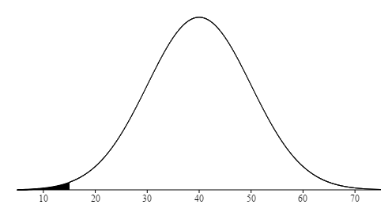

2. Given a normal curve with a mean of 20 and a standard deviation of 3, find the X value such that only 10% of the cases are below it.
- We need the bottom 10%, but since we need to use the area between the mean and that cutoff in the table, we subtract 50 – 10 = 40.  - We enter Table B1 with 40, find the closest z-score of 1.28.  - Since we are dealing with the negative side of the curve, we use -1.28 and recalculate it into X score: X = 20 + (-1.28*3) = 16.16. | 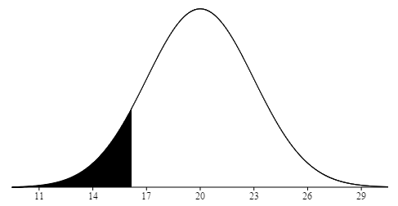
Answer: 16.16 is the value of X such that only 10% of cases are below it.

3. Given a normal curve with a mean of 100 and a standard deviation of 5, find the percentage of scores between 80 and 110.
- We calculate z-scores for both values: z1=(80-100)/5 = -4, z2 = (110-100)/5 = 2.  - We enter Table B1 with both of those z scores, get areas 49.99 and 47.72, respectively.  - We add these two areas together, 49.99+47.72=97.71.  Answer: 97.71% of scores are between 80 and 110. | 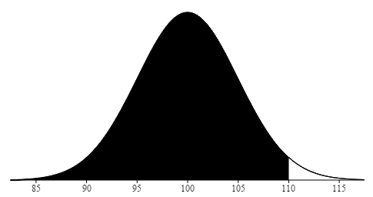

4. Given a normal curve with a mean of 30 and a standard deviation of 8, find the two values of X that include the middle 60% of the distribution.
- Since the curve is symmetric, to get the middle 60%, we will start with the right half that will contain 30%. We enter Table B1 and find z-score most closely corresponding to area=30: z=0.84.  - Next, we calculate X scores for both z = 0.84 and z = -0.84, since the middle 60% is divided two 30% chunks. X1 = 30 + (0.84*8) = 36.72, X2 = 30 + (-.84*8) = 23.28. | 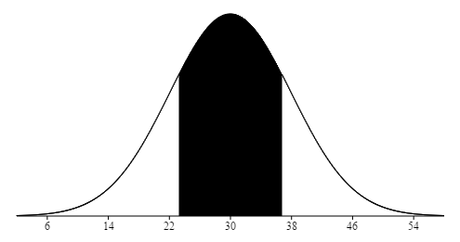
Answer: The middle 60% of the distribution is between scores 23.28 and 36.72.

