SOCY2200 Instructor: Natasha Sarkisian
Week 3 Worksheet Exercises: Answers

Part I. Critiquing Graphs Exercise
- Are these univariate or bivariate graphs? What types of graphs? What variable or variables do these represent? What is the level of measurement for these variables? What are the observational units here? Which graph better represents information and why?
Univariate. Pie chart and bar graph. Variable: Industry of employment. Nominal. Units: Residents of Colorado. Bar chart is better because it’s easier to see which industries are the biggest employers; the differences in size are also very clear and not distorted by 3D special effects.
What Industries Employ Coloradians?
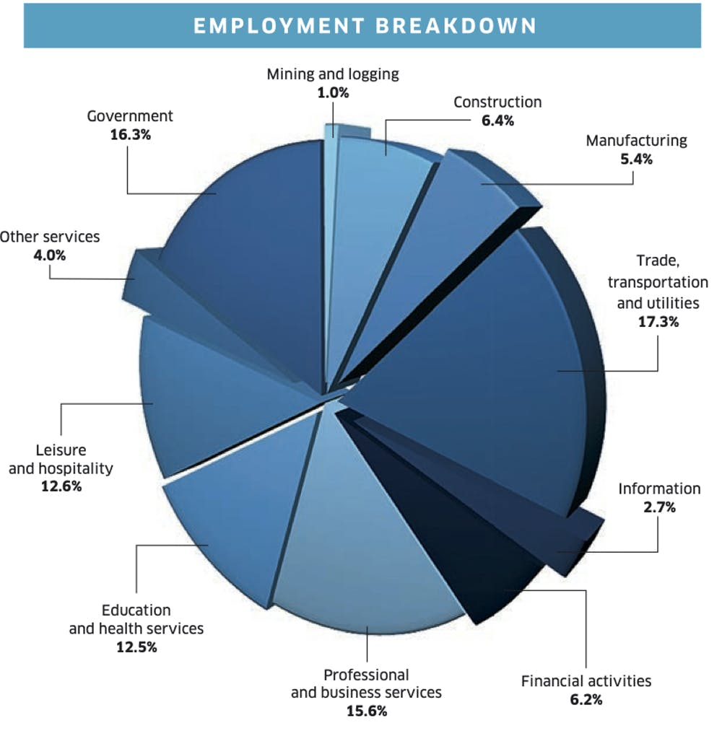
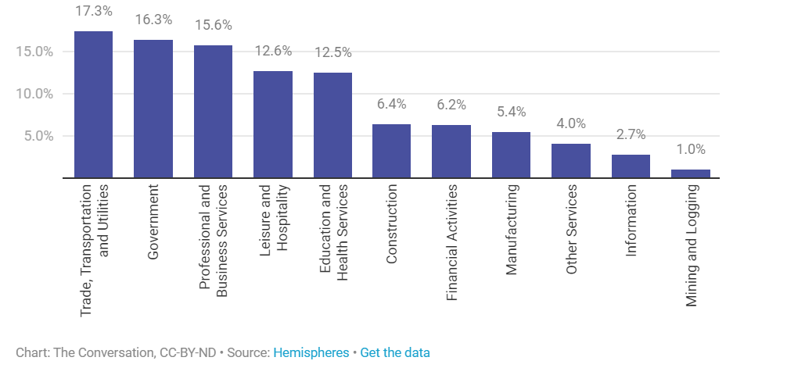
- Is this a univariate or bivariate graph? What type of graph? What variable or variables does it represent? What is the level of measurement for these variables? What are the observational units here? Which of the two versions of the graph better represents the data and why? What criticisms can you offer for these graphs?
Univariate pie chart; variable – religious affiliation; nominal. Units: individuals. Criticism: 3D graph is misleading because Muslims category gets more ink even though it is smaller than the Christians category. Also, many slices are not labeled at all, and the graph does not clarify which countries were included, and whether this is only adults or children as well.
Religions of the World
Version 1 Version 2
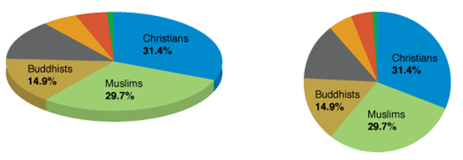
- Is this a univariate or bivariate graph? What type of graph? What variable or variables does it represent? What is the level of measurement for these variables? What criticisms can you offer for this graph?
Bivariate bar chart. Variables: Country (nominal) and GDP (ratio). Criticism: The bars do not start at 0, and GDP values are not equally spaced, so proportional ink principle is violated.
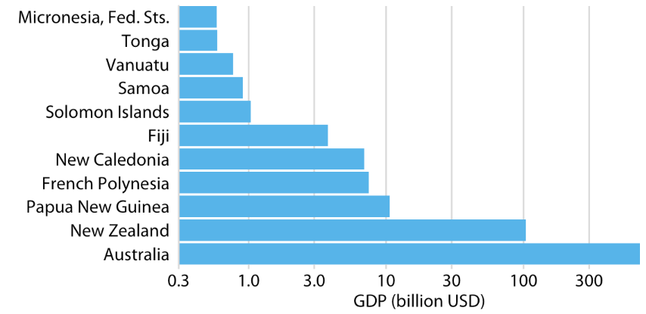
- Is this a univariate or bivariate graph? What type of graph? What variable or variables does it represent? What is the level of measurement for these variables? What criticisms can you offer for this graph?
Pie charts should always be univariate, so we can say that – but in this case, it is really trivariate (and incorrect); variable: engagement in dangerous behaviors (but really three variables, one for each behavior), nominal. Units: High school students. Criticism: The three pie pieces do not add up to 100% - in fact, it seems that these categories are separate variables and were not treated as mutually exclusive. Also, 3D pie chart misrepresents the three percentages because the front ones get too much “ink.”
Percentage of High School Students Who Engage in Some Dangerous Behaviors
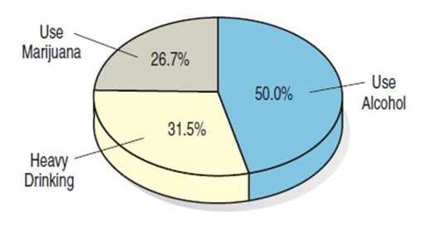
- Is this a univariate or bivariate graph? What type of graph? What variable or variables does it represent? What is the level of measurement for these variables? What are the observational units here? What criticisms can you offer for this graph?
Bivariate line chart. Variables: time in years (interval) and whether an adult in Alcorcon is unemployed (nominal). Unit of observation: an adult in Alcorcon. [Alternatively, we could consider Alcorcon as a unit of observation and number of unemployed as a variable; it is ratio in that case.] Criticism: Vertical scale is not labeled, values on the red part are not on the same height and similar values in the black part (15,293 is lower than 13,309); also, time scale is not even (annual before 2011, monthly after 2013) and there is a gap in data. There are bars under the curve that add to the misleading visual, violating the proportional ink principle. Compare:
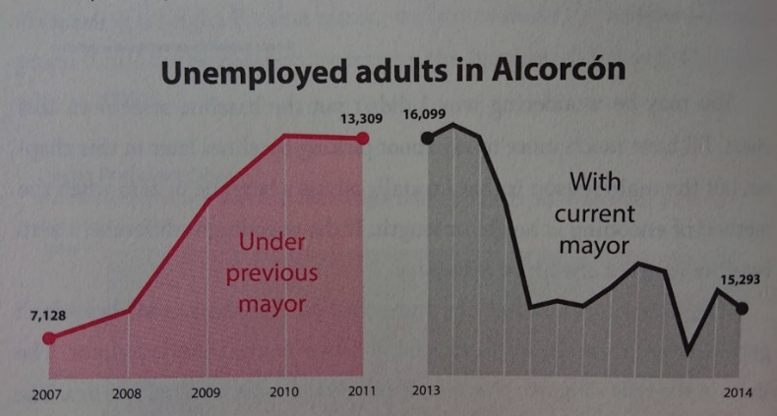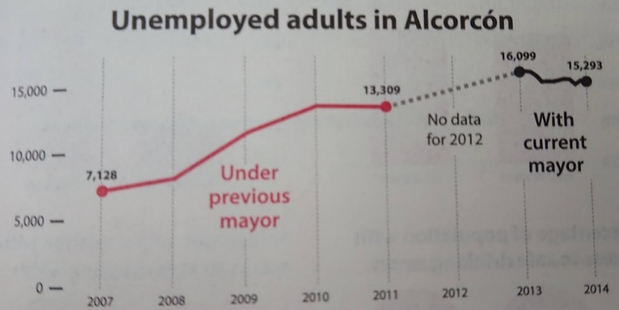

6. Find a bar graph, a pie chart or a line graph in a news media article. Describe what the chart is showing. Is it clear or confusing? Do you fully understand this chart? Why or why not? What criticisms of the chart, if any, do you have?
Answers vary.
Part II. Graphs in Stata

Open a log file called exercise2.log. Then, using the General Social Survey 2012 data (gss2012.dta, available from Canvas), conduct the following analyses and answer the questions below.

1. Obtain codebook information and frequency distributions for four variables: conpress, conlegis, hrs1, and life. Indicate the level of measurement (nominal, ordinal, interval, ratio) for each of the variables:
conpress ___ordinal_________________________

conlegis ___ordinal_________________________

hrs1 ___ratio_________________________

life _nominal (or ordinal, if we consider dull more extreme than routine)_____________________

2. Indicate the graph types that are appropriate for each of these variables:

 | Conpress | Conlegis | Hrs1 | Life
Bar graph | + | + | - | +
Pie chart | + | + | - | +
Histogram | - | - | + | -
Boxplot | - | - | + | -
Stem-and-leaf plot | - | - | + | -
Frequency polygon | - | - | + | -
Ogive | - | - | + | -

3. Construct bar graphs for the variables conpress and conlegis; include percentage labels. Export the graphs into png format. Insert these two graphs into this Word file (make sure to include a header indicating which graph is which!). Based on these two graphs, how would you describe the relative level of confidence in press and in the U.S. Congress?

Americans have higher levels of confidence in press than in U.S. Congress, but for both, the levels are quite low – only 9% of Americans have a great deal of confidence in press, and only 6.7% have a great deal of confidence in the U.S. Congress; at the same time, 46.8% of people have hardly any confidence in press and 49.3% have hardly any confidence in Congress.

4. Construct a histogram (with a normal curve) and a boxplot for the variable hrs1. Export these graphs and add them to this word file (once again, make sure to add a header for each). What does each of these graphs tell us about the distribution of values for this variable?

The histogram shows that a lot of people report working exactly 40 hours; that’s the mode and has a very high frequency. That is one thing that is clearly making the distribution depart from normal. It shows that the distribution is fairly symmetric, there does not appear to be any skew, although the right tail is a bit more uneven and looks like it contains more pronounced outliers. The boxplot shows that 40 is also the median, the majority of people work from around 15 to 70 hours a week, and those outside that range can be considered outliers at both ends of the distribution. Boxplot also allows us to see the 25th and 75th percentiles (34 hours and 48 hours, although to get exact numbers, we should use summary statistics commands).

5. Obtain skewness and kurtosis statistics for the variable hrs1.
Skewness statistic value: _______________ .06

Kurtosis statistic value: _______________3.65

What do these statistics tell us about the distribution of hrs1?
The distribution is approximately normal with regard to both skewness and kurtosis (not skewed and mesokurtic).

6. Construct a pie chart for the variable life; include percentage labels. Export this graph and add it to the word file as well (once again, with a header). Based on this graph, what do the majority of people in this sample think about their life?

The majority (51.85%) report that they think their life is exciting.

Part III. Descriptive Statistics in the News.
Read this article: https://www.theguardian.com/us-news/2025/aug/21/ceo-worker-salaries and the summary of the report that it is based on: https://ips-dc.org/report-executive-excess-2025/.

Download this dataset that the report is based on, called CEO_pay.dta: https://www.sarkisian.net/CEO_pay.dta. Upload it to Stata folder on AppStream using the same process we used for gss2012.dta. Open this data file and calculate descriptive statistics for three variables: CEO pay, median worker pay, and ratio of the two. Also, obtain measures of skewness and kurtosis for each of these variables and construct both histograms and boxplots for each of them (export these graphs and add them to this word file with appropriate headers). Fill out this table:
 | Mean | Median | Central tendency from the report | Skewness | Kurtosis
CEO pay | $17.2 mln | $16.5 mln | $17.2 mln | 3.53 | 23.08
Median worker pay | $35,570 | $38,681 | $35,570 | -.55 | 1.98
Ratio of CEO pay to worker pay | 632 | 447 | 632 | 5.38 | 41.70

- Which measures of central tendency are presented in the report -- means or medians? Circle the answer.

Means Medians

- Examine all the graphs and statistics you obtained. Do you think means or medians better represent central tendency for each of these variables, and if so, and why? Please circle the answer and explain:

For CEO pay: Mean Median Why? The variable is positively skewed and has outliers. __________________________________________________

For median worker pay: Mean Median Why? This variable is not skewed (approximately normal) and doesn’t have outliers, so we can use the mean, although it would also be ok to use the median if we wanted to compare worker pay to CEO pay

For the ratio of the two: Mean Median Why? The variable is positively skewed and has outliers.

Graphs You Generated in Stata
(insert below with headers):
Included in the log file:

. log using exercise2.log
-------------------------------------------------------------------------------
name: <unnamed>
log: exercise2.log
log type: text

. use gss2012.dta, clear

. codebook conpress conlegis hrs1 life

------------------------------------------------------------------------------------------
conpress CONFIDENCE IN PRESS
------------------------------------------------------------------------------------------

type: numeric (byte)
label: LABU

range: [1,3] units: 1
unique values: 3 missing .: 664/1,974

tabulation: Freq. Numeric Label
119 1 A GREAT DEAL
578 2 ONLY SOME
613 3 HARDLY ANY
664 .

------------------------------------------------------------------------------------------
conlegis CONFIDENCE IN CONGRESS
------------------------------------------------------------------------------------------

type: numeric (byte)
label: LABU

range: [1,3] units: 1
unique values: 3 missing .: 679/1,974

tabulation: Freq. Numeric Label
87 1 A GREAT DEAL
569 2 ONLY SOME
639 3 HARDLY ANY
679 .

------------------------------------------------------------------------------------------
hrs1 NUMBER OF HOURS WORKED LAST WEEK
------------------------------------------------------------------------------------------

type: numeric (byte)
label: LABAD, but 68 nonmissing values are not labeled

range: [1,89] units: 1
unique values: 68 missing .: 808/1,974

examples: 40
45
.
.

------------------------------------------------------------------------------------------
life IS LIFE EXCITING OR DULL
------------------------------------------------------------------------------------------

type: numeric (byte)
label: LIFE

range: [1,3] units: 1
unique values: 3 missing .: 678/1,974

tabulation: Freq. Numeric Label
672 1 exciting
562 2 routine
62 3 dull
678 .

. tab1 conpress conlegis hrs1 life

-> tabulation of conpress

CONFIDENCE |
IN PRESS | Freq. Percent Cum.
-------------+-----------------------------------
A GREAT DEAL | 119 9.08 9.08
ONLY SOME | 578 44.12 53.21
HARDLY ANY | 613 46.79 100.00
-------------+-----------------------------------
Total | 1,310 100.00

-> tabulation of conlegis

CONFIDENCE |
IN CONGRESS | Freq. Percent Cum.
-------------+-----------------------------------
A GREAT DEAL | 87 6.72 6.72
ONLY SOME | 569 43.94 50.66
HARDLY ANY | 639 49.34 100.00
-------------+-----------------------------------
Total | 1,295 100.00

-> tabulation of hrs1

NUMBER OF |
HOURS |
WORKED LAST |
WEEK | Freq. Percent Cum.
------------+-----------------------------------
1 | 2 0.17 0.17
2 | 1 0.09 0.26
4 | 6 0.51 0.77
5 | 3 0.26 1.03
7 | 1 0.09 1.11
8 | 11 0.94 2.06
9 | 41 3.52 5.57
10 | 6 0.51 6.09
11 | 1 0.09 6.17
12 | 7 0.60 6.78
14 | 1 0.09 6.86
15 | 13 1.11 7.98
16 | 14 1.20 9.18
17 | 2 0.17 9.35
18 | 5 0.43 9.78
19 | 3 0.26 10.03
20 | 46 3.95 13.98
21 | 3 0.26 14.24
22 | 3 0.26 14.49
23 | 1 0.09 14.58
24 | 15 1.29 15.87
25 | 17 1.46 17.32
26 | 1 0.09 17.41
27 | 2 0.17 17.58
28 | 3 0.26 17.84
29 | 1 0.09 17.92
30 | 47 4.03 21.96
31 | 2 0.17 22.13
32 | 25 2.14 24.27
33 | 3 0.26 24.53
34 | 6 0.51 25.04
35 | 32 2.74 27.79
36 | 17 1.46 29.25
37 | 11 0.94 30.19
38 | 21 1.80 31.99
39 | 4 0.34 32.33
40 | 349 29.93 62.26
41 | 6 0.51 62.78
42 | 18 1.54 64.32
43 | 10 0.86 65.18
44 | 14 1.20 66.38
45 | 57 4.89 71.27
46 | 14 1.20 72.47
47 | 6 0.51 72.98
48 | 28 2.40 75.39
49 | 3 0.26 75.64
50 | 76 6.52 82.16
52 | 7 0.60 82.76
53 | 5 0.43 83.19
55 | 33 2.83 86.02
56 | 4 0.34 86.36
57 | 3 0.26 86.62
58 | 4 0.34 86.96
59 | 2 0.17 87.14
60 | 75 6.43 93.57
62 | 3 0.26 93.83
63 | 1 0.09 93.91
64 | 3 0.26 94.17
65 | 13 1.11 95.28
68 | 3 0.26 95.54
70 | 21 1.80 97.34
72 | 3 0.26 97.60
75 | 2 0.17 97.77
77 | 1 0.09 97.86
80 | 15 1.29 99.14
85 | 1 0.09 99.23
86 | 1 0.09 99.31
89 | 8 0.69 100.00
------------+-----------------------------------
Total | 1,166 100.00

-> tabulation of life

IS LIFE |
EXCITING OR |
DULL | Freq. Percent Cum.
------------+-----------------------------------
exciting | 672 51.85 51.85
routine | 562 43.36 95.22
dull | 62 4.78 100.00
------------+-----------------------------------
Total | 1,296 100.00

. graph bar, over(conpress) blabel(bar)

. graph export conpress.png
(file conpress.png written in PNG format)

. graph bar, over(conlegis) blabel(bar)
. graph export conlegis.png
(file onlegis.png written in PNG format)

. tabstat hrs1, stats(skewness kurtosis)

variable | skewness kurtosis
-------------+--------------------
hrs1 | .0575558 3.649988
----------------------------------

. histogram hrs1, normal
. graph export histogram_hrs1.png
(file histogram_hrs1.png written in PNG format)

. graph box hrs1

. graph export boxplot_hrs1.png
(file boxplot_hrs1.png written in PNG format)

. graph pie, over(life) plabel(_all percent)

. graph export life.png
(file life.png written in PNG format)

. use CEO_pay.dta, clear

. tabstat CEO_pay_mln_2024 median_worker_pay_2024 ratio_2024,
> stats(mean median range iqr sd skewness kurtosis)

Stats | C~n_2024 m~y_2024 r~o_2024
---------+------------------------------
Mean | 17.221 35569.63 632.1
p50 | 16.5 38681.5 447
Range | 95.5 44445 6658
IQR | 10.7 21887.5 377
SD | 11.8369 13013.77 757.1383
Skewness | 3.531056 -.5488434 5.376989
Kurtosis | 23.0763 1.982294 41.6985
----------------------------------------

. histogram CEO_pay_mln_2024
(bin=10, start=.3, width=9.55)
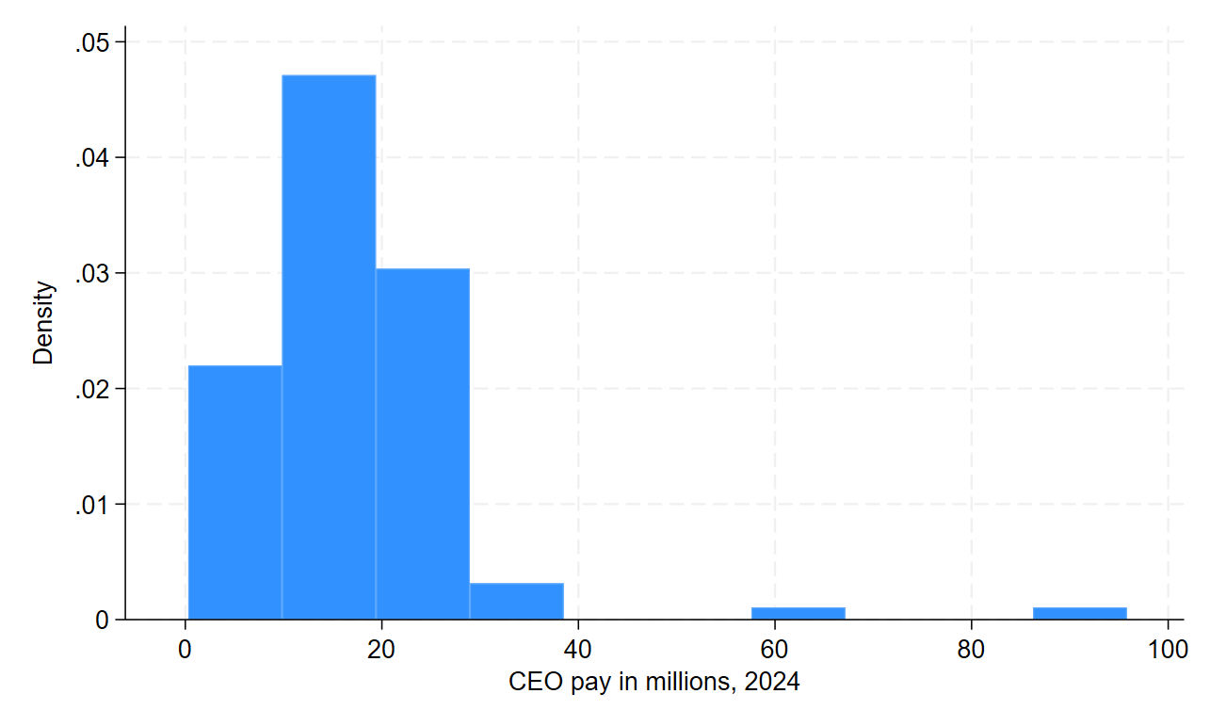
. graph export CEO_histogram.png
file CEO_histogram.png saved as PNG format

. histogram median_worker_pay_2024
(bin=10, start=9052, width=4444.5)
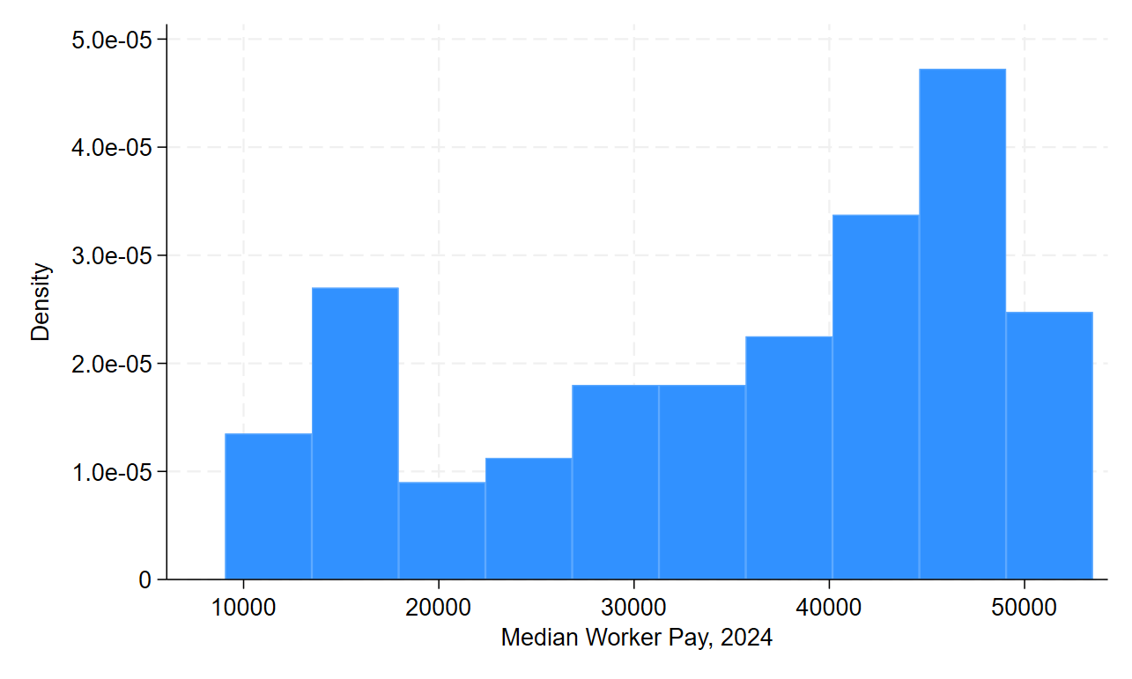
. graph export worker_histogram.png
file worker_histogram.png saved as PNG format

. histogram ratio_2024
(bin=10, start=8, width=665.8)
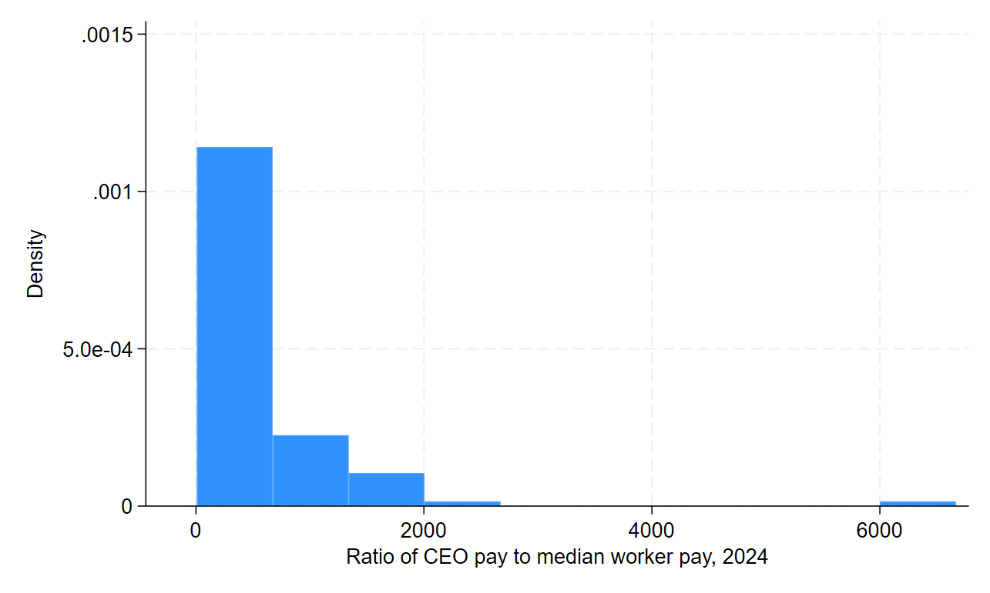
. graph export ratio_histogram.png
file ratio_histogram.png saved as PNG format

. graph box CEO_pay_mln_2024
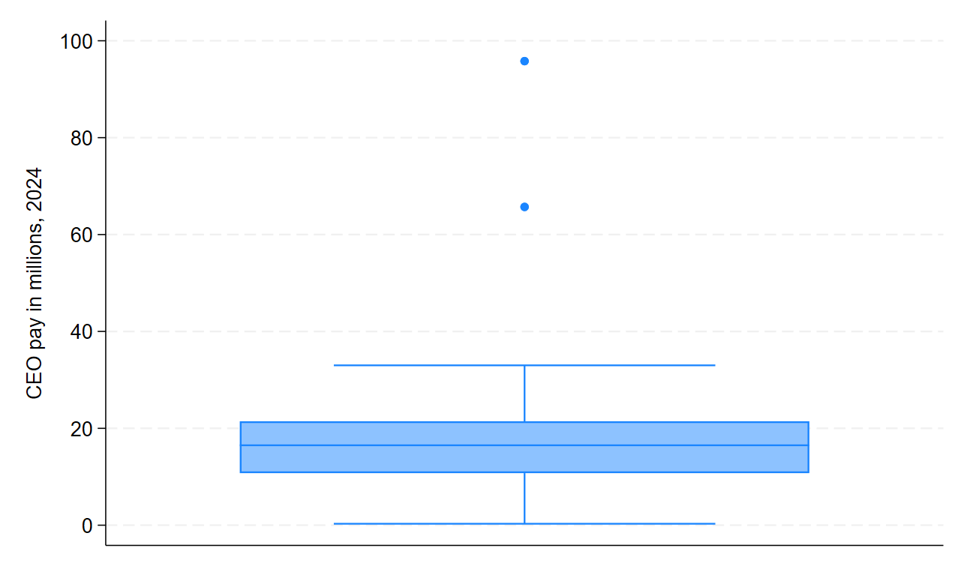
. graph export CEO_box.png
file CEO_box.png saved as PNG format

. graph box median_worker_pay_2024
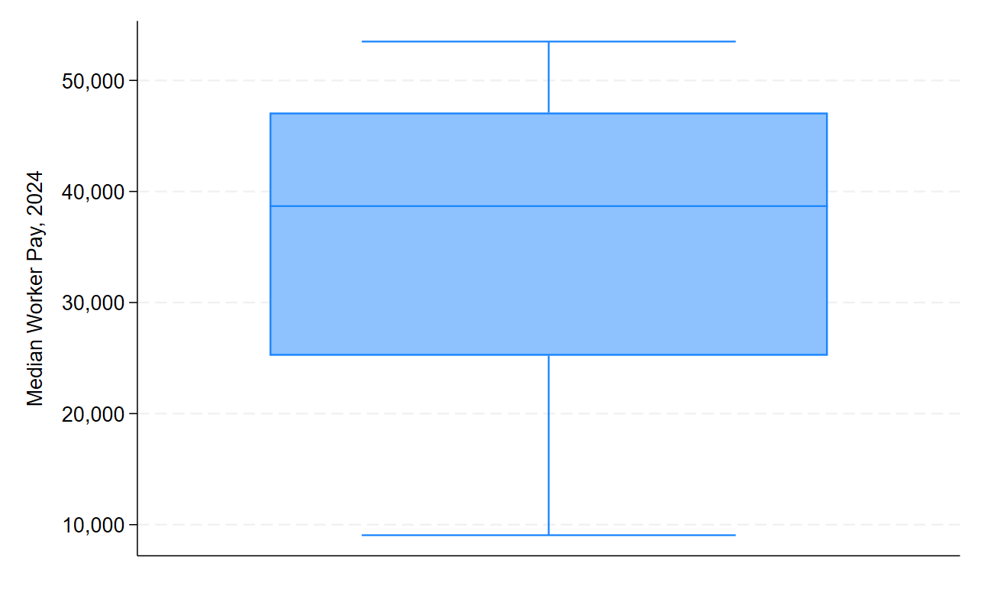
. graph export worker_box.png
file worker_box.png saved as PNG format

. graph box ratio_2024
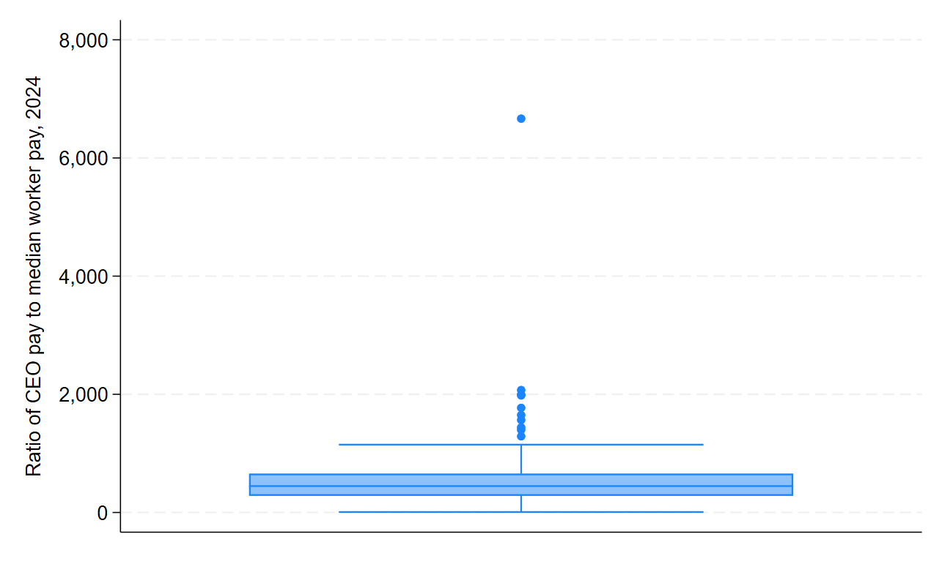
. graph export ratio_box.png
file ratio_box.png saved as PNG format

. log close
name: <unnamed>
log: exercise3.log
log type: text

